VOTING BY ABSENTEE BALLOT
Any qualified elector who is unable or unwilling to appear at the polling place on Election Day may submit a request to vote an absentee ballot to their municipal clerk. A qualified elector is any U.S. citizen who:
- will be 18 years of age or older on Election Day.
- has resided in the ward or municipality where they wish to vote for at least 28 consecutive days before the election.
The elector must also be registered to vote to receive an absentee ballot. Proof of identification must be provided before an absentee ballot may be issued*.
Making application to receive an absentee ballot by mail
Contact your municipal clerk and request that an application for an absentee ballot be sent to you for the primary or election or both. You may make written application to your municipal clerk for an absentee ballot in person, by mail, by fax, by email or at MyVote.wi.gov.
Your written request must include:
- your voting address within the municipality where you wish to vote
- the address where the absentee ballot should be sent, if different from the address above
- your signature
- a copy of your photo identification
The deadline for making application to receive an absentee ballot by mail is: 5:00 p.m. on the fifth day before the election, Thursday, April 2, 2026.
*Voters who are indefinitely confined due to age, illness, infirmity, or disability may not be required to provide photo ID. If this applies to you, contact the municipal clerk regarding deadlines for requesting and submitting an absentee ballot.
**Special absentee voting application provisions apply to electors who are indefinitely confined, in the military, hospitalized, or serving as a sequestered juror. If this applies to you, contact the municipal clerk regarding deadlines for requesting and submitting an absentee ballot.
Voting an absentee ballot in person
You may also request and vote an absentee ballot in the clerk's office or other specified location during the days and hours specified for casting an absentee ballot in person.
The first day to vote an absentee ballot in the clerk’s office is determined by your Municipal Clerk. *Please refer to your Municipal Clerk’s information for in-person absentee ballot voting below.
The last day to vote an absentee ballot in the clerk's office is determined by your Municipal Clerk. *Please refer to your Municipal Clerk’s information for in-person absentee ballot voting below.
No in-person absentee voting may occur on the day before the election. The municipal clerk will deliver voted ballots returned on or before Election Day to the proper polling place or counting location before the polls close on April 7, 2026. Any ballots received after the polls close will not be counted.

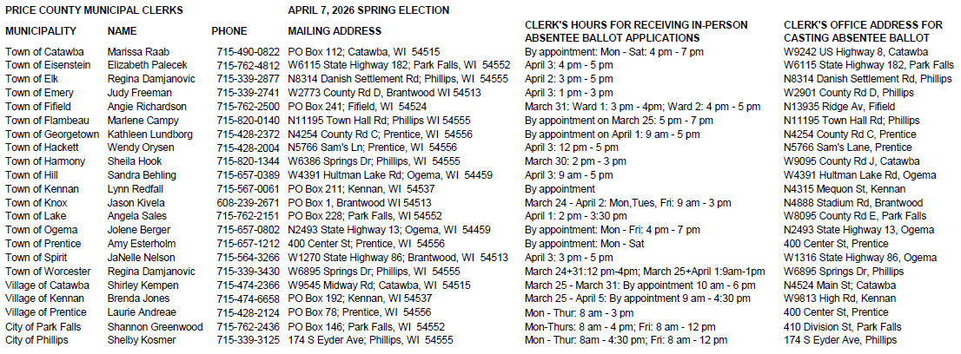
s/Meredith Hueckman, Price County Clerk

